Perhitungan :

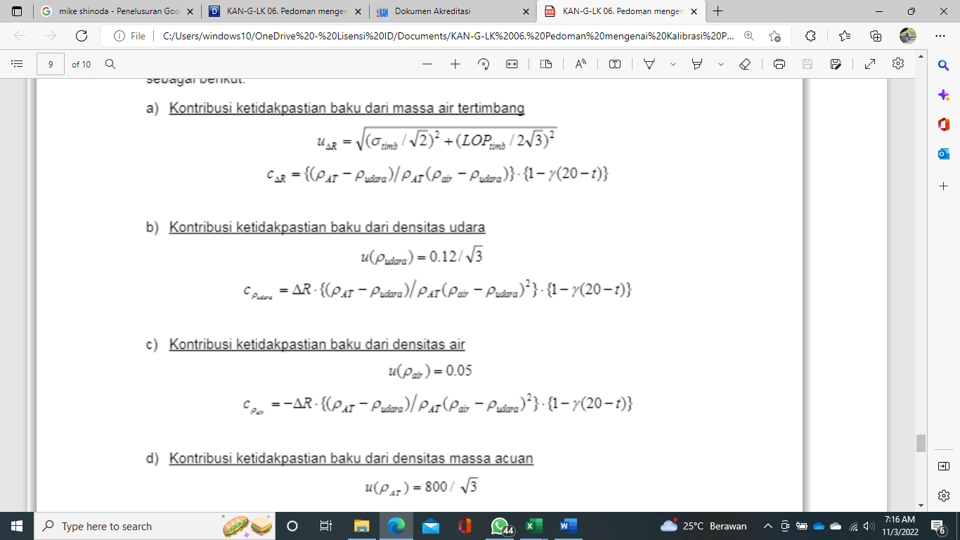

Perhitungan :

Perhitungan :

Perhitungan :

Perhitungan :

Perhitungan :

Perhitungan :

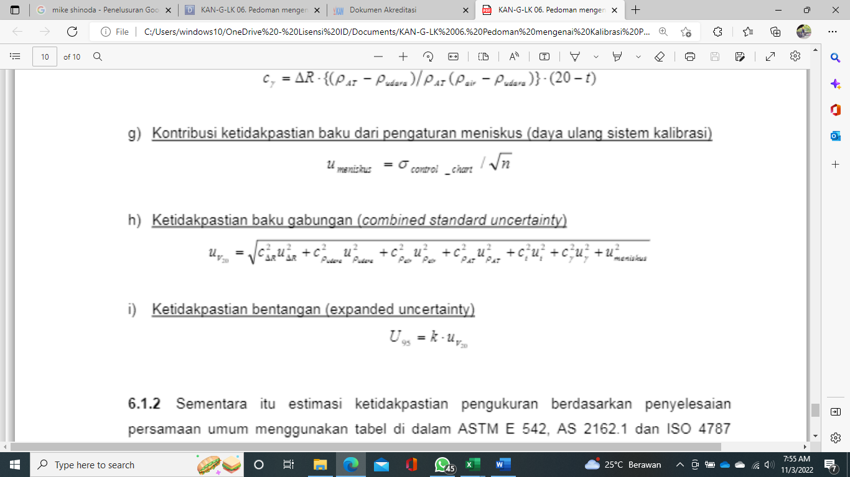

Nilai ketidakpastian gabungan merupakan gabungan point a – g kemudian masing – masing dikuadratkan seperti rumus diatas.

Perhitungan :

Nilai ketidakpastian gabungan merupakan nilai point h dikalikan 2. Nilai ini yang nanti masuk kedalam kolom ”ketidakpastian” di sertifikat kalibrasi